Loading Screen

Main Alert Button

Sign Up Page

Sign In Page

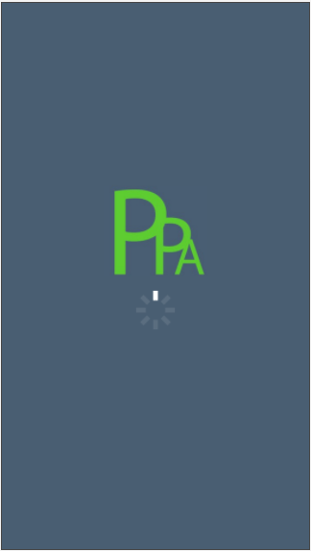

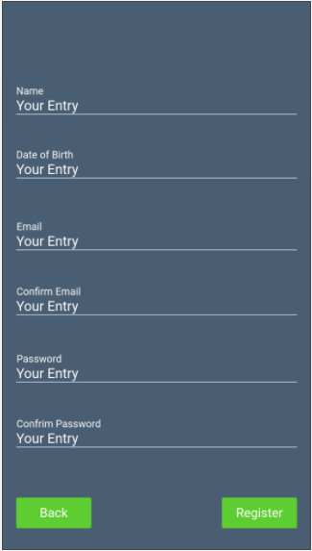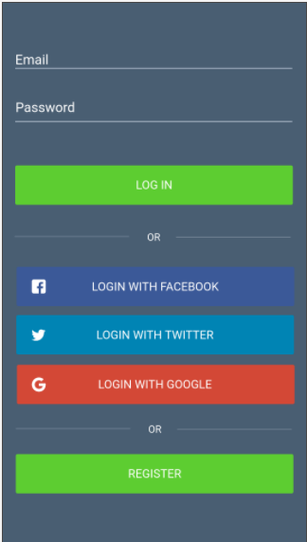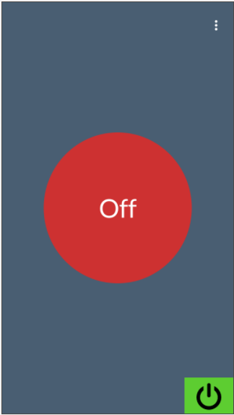

This is to act as a loading screen, or just a splash screen.

This is the main alert button page before it has been pressed. A vibrant red has been used, as this is to signify that the button is switched off. In the bottom left right corner is an off button. This sis so that the user can deactivate the whole app and stop it from constantly listening. The three dots at the top take the user to their contacts.

This is the login page. Users have the option to login with a choice of social media or their email. However, if the user does not have an account, then they can easily go to the register button, and move on to creating one.

This is the register page. From here the users can go back to the sign up page or they can progress on by registering. This will then take the user to the main alert button page.

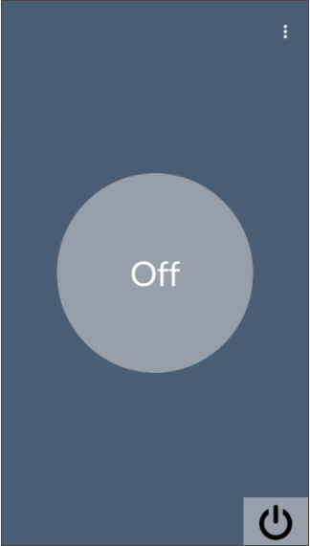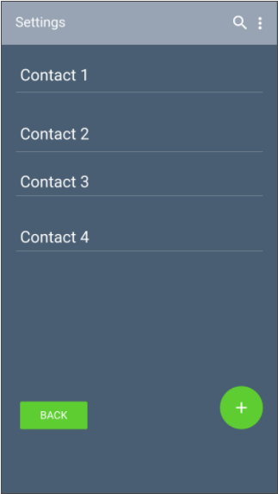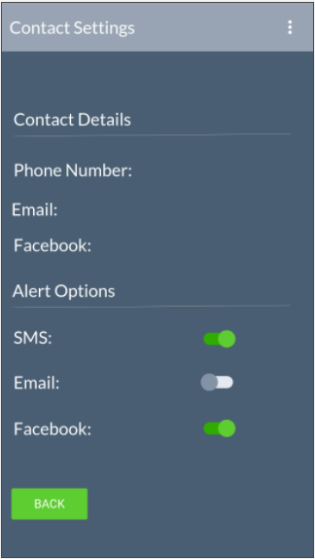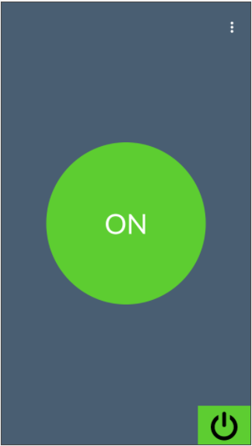

Alert Button On

App Deactivated

Contacts Page

Settings Page

From this page users can select how they would like their contacts to receive the S.O.S message. This page also allows the user to change any of the details for the contact.

This page shows a list of the user’s contacts. When a contact is selected, the user will be taken to the settings for that contact.

This is the alert button when it has been pressed, showing as green meaning that help has been sent for.

After the power button in the bottom left right corner has been pressed the whole app will be deactivated and will stop listening, and when the button is pressed nothing will happen.

## Colour Codes:

Red: #CD3131

Green: #5DCD31

Background Colour: #495E72

# Final Implemented Design

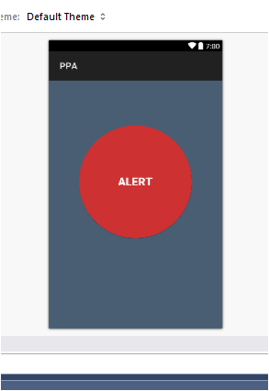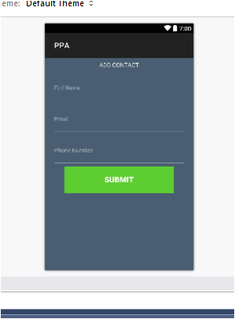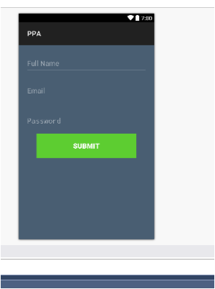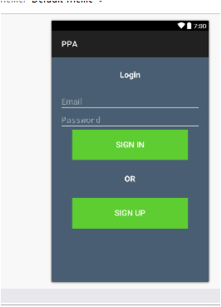

This is the final version of the login page. It still has the same basic elements as the original design, excluding the option to sign in with social media.

This is the final alert button page. From here the user can press the button to send an alert message to their contact. On being pressed the button turns green temporarily to signify that the alert is being sent. As well as this a toast message will appear to clarify this and notify when the alert has been sent.

After signing up, the user is then taken to this page. From here they can add only one contact, before progressing on to the main page.

This is the final sign up page. The information required has been stripped back to the essential. The buttons are kept consistent, all being the same colour and similar size.